**Tugas Algoritma dan Struktur Data**



**Nama : Sarnila Sari Saputri**

**NIM : L200150077**

**Kelas : B**

PROGDI INFORMATIKA

UNIVERSITAS MUHAMMADIYAH SURAKARTA

1. **Berikut ini adalah program untuk menampilkan daftar kode ASCII**

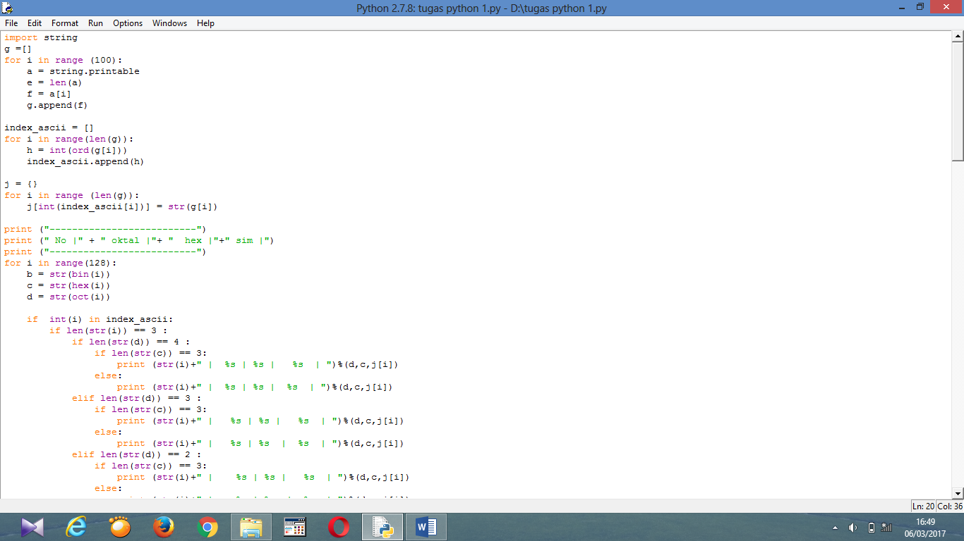

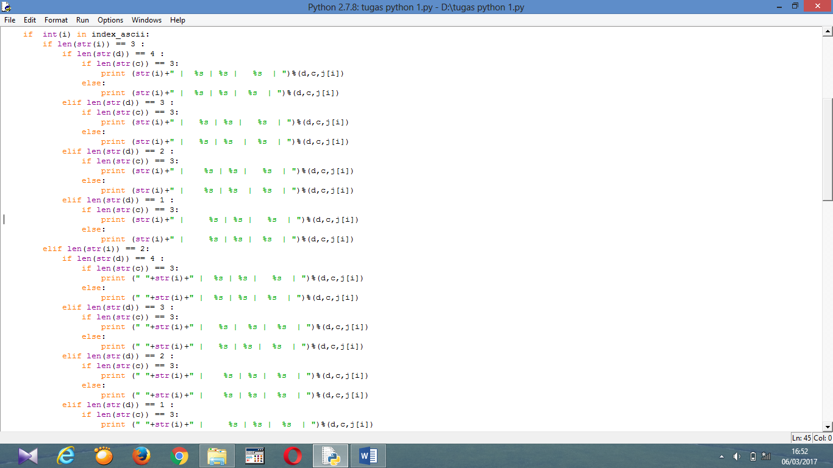

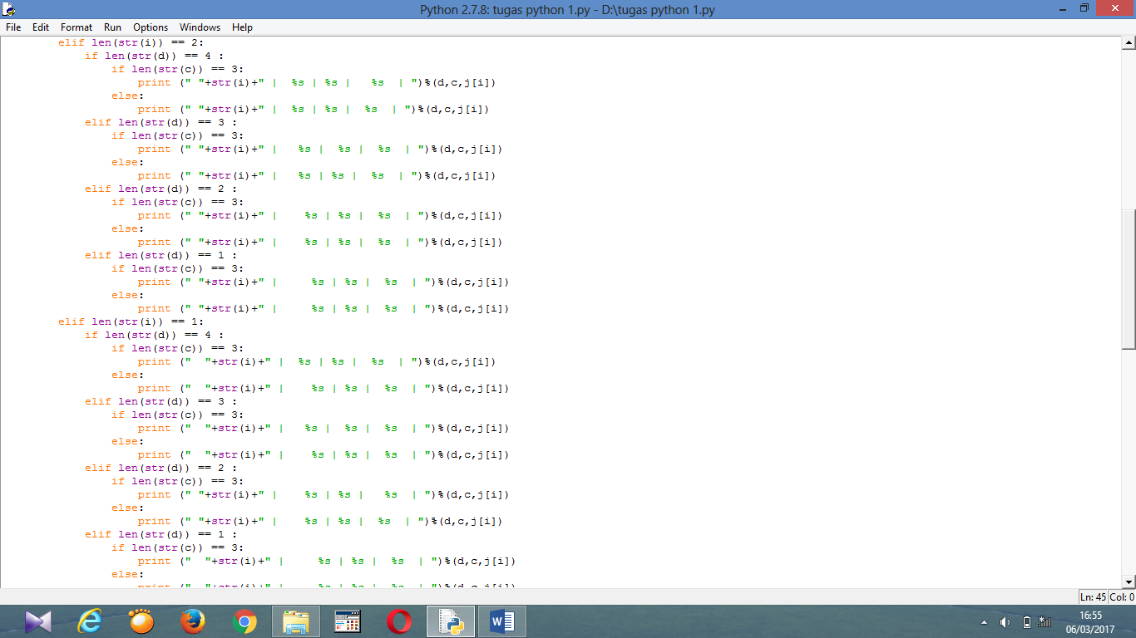

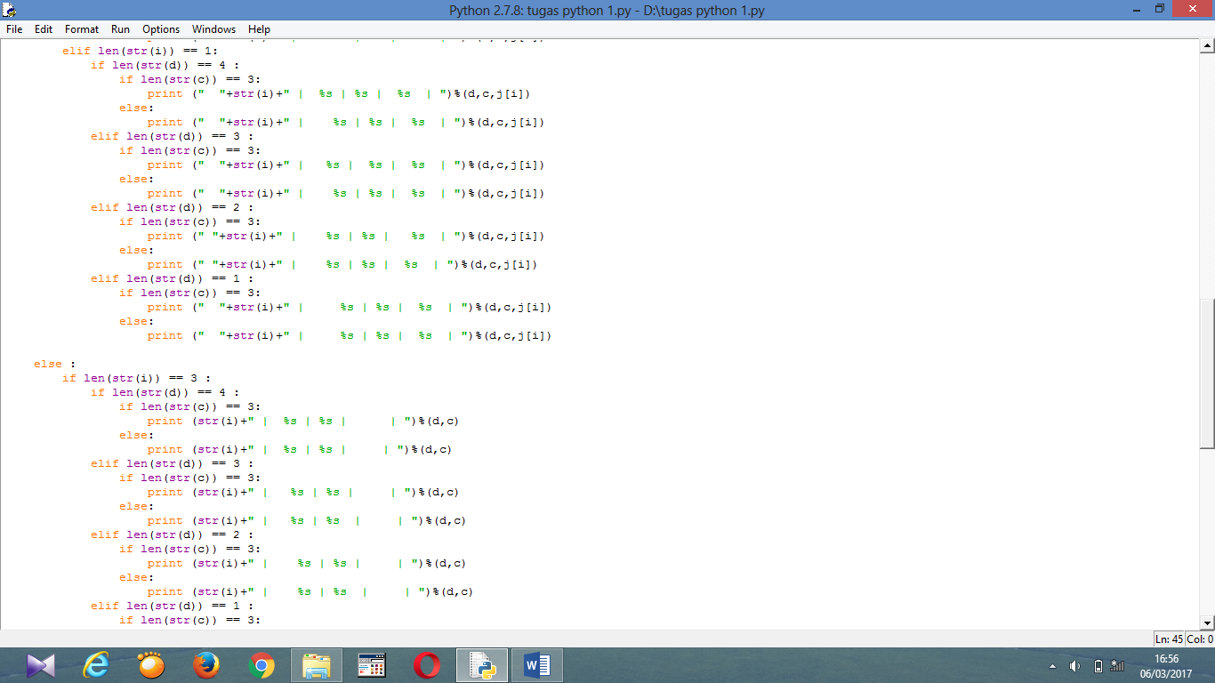

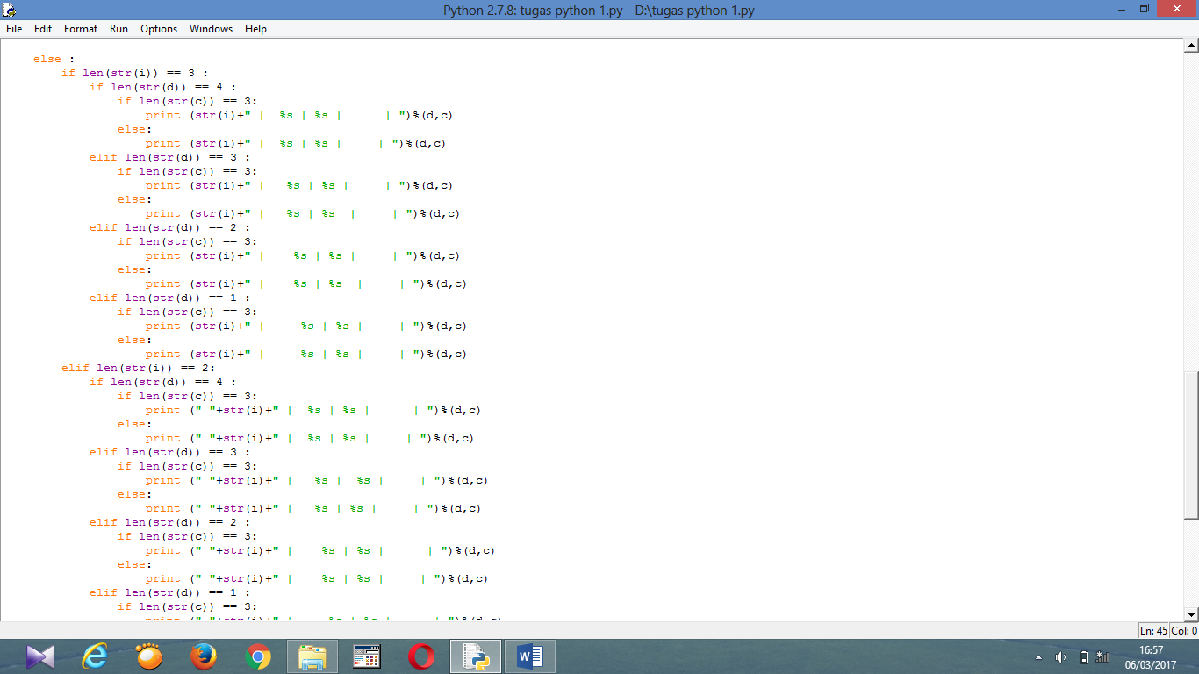

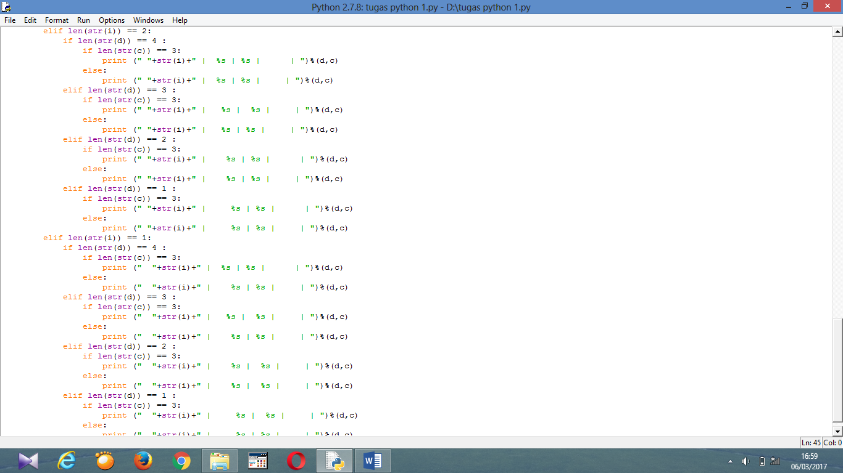

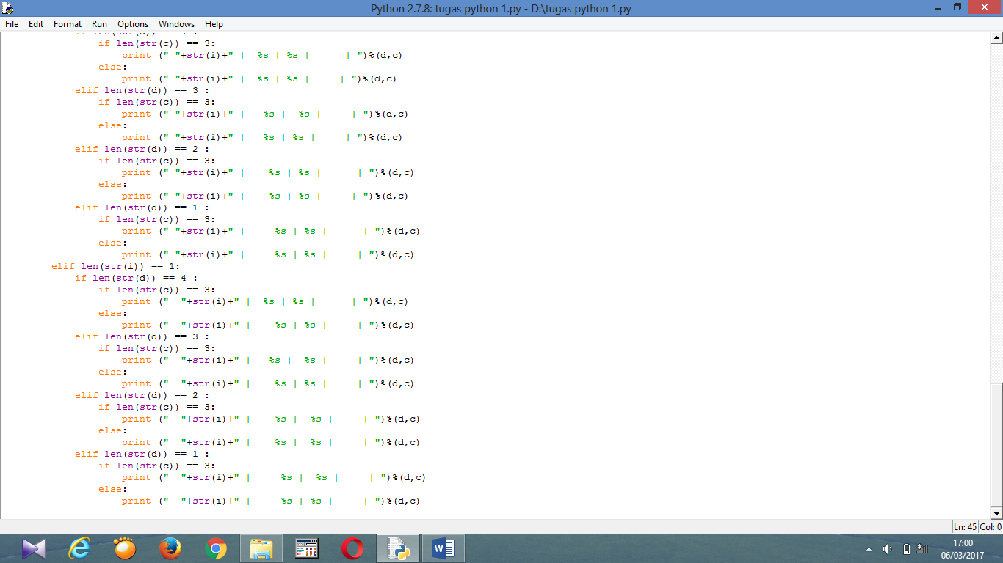

Dan setelah program diatas dijalankan,maka akan di dapatkan output seperti berikut :

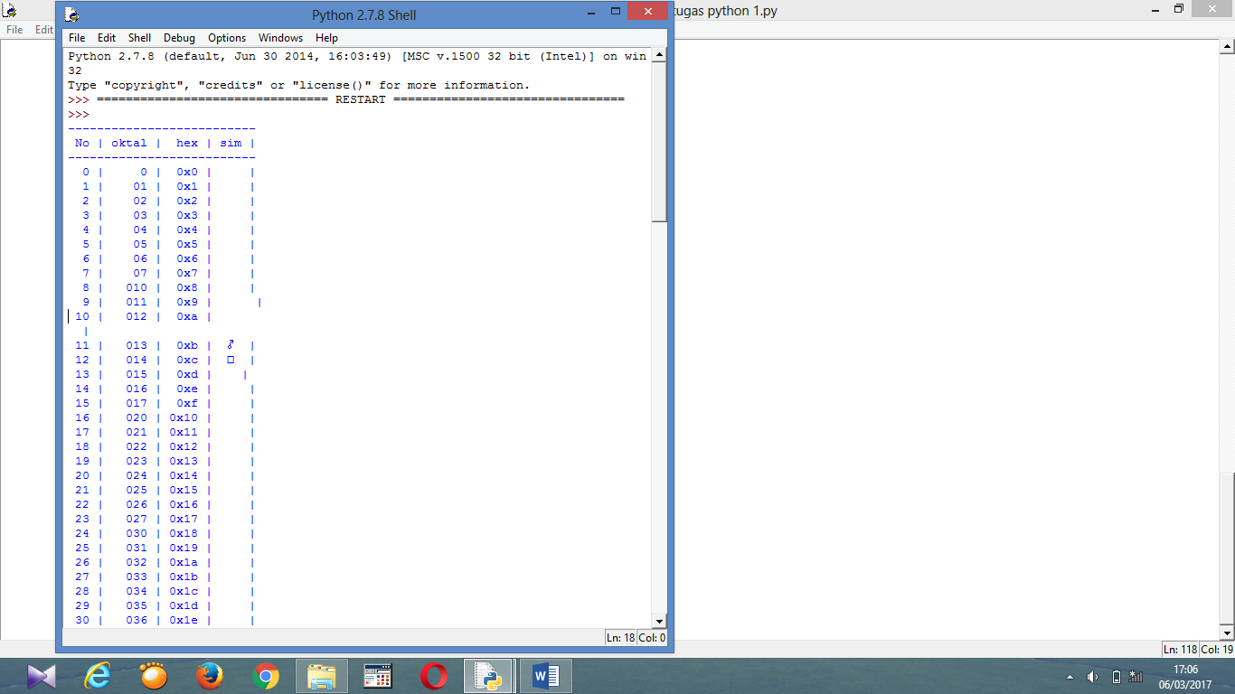

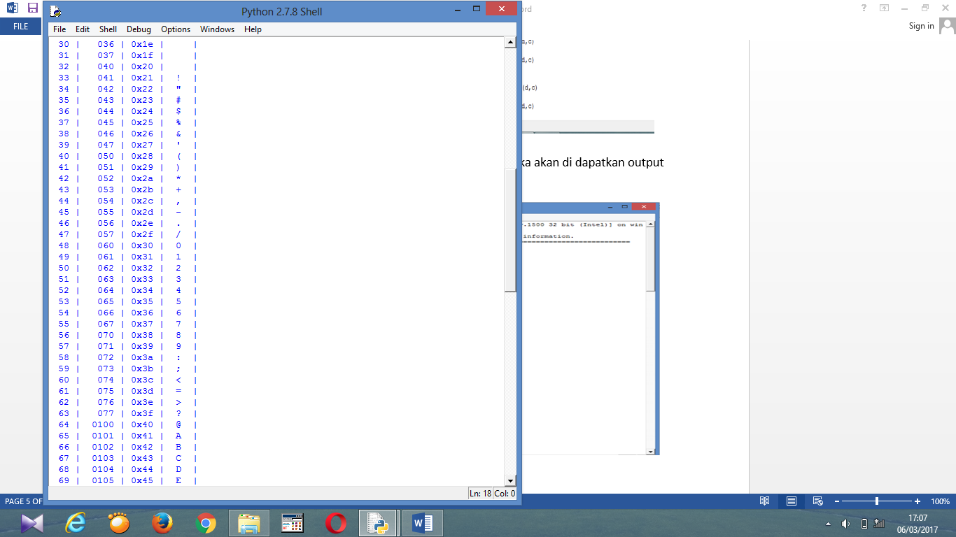

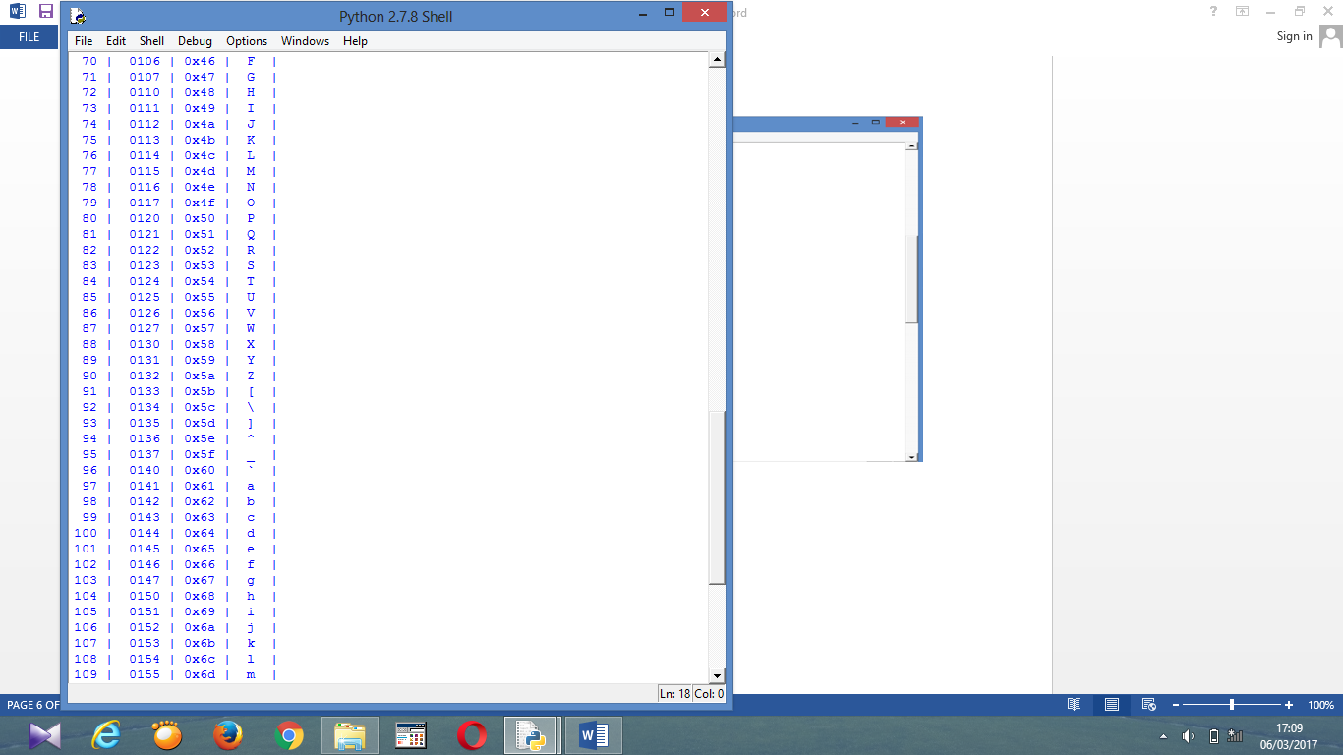

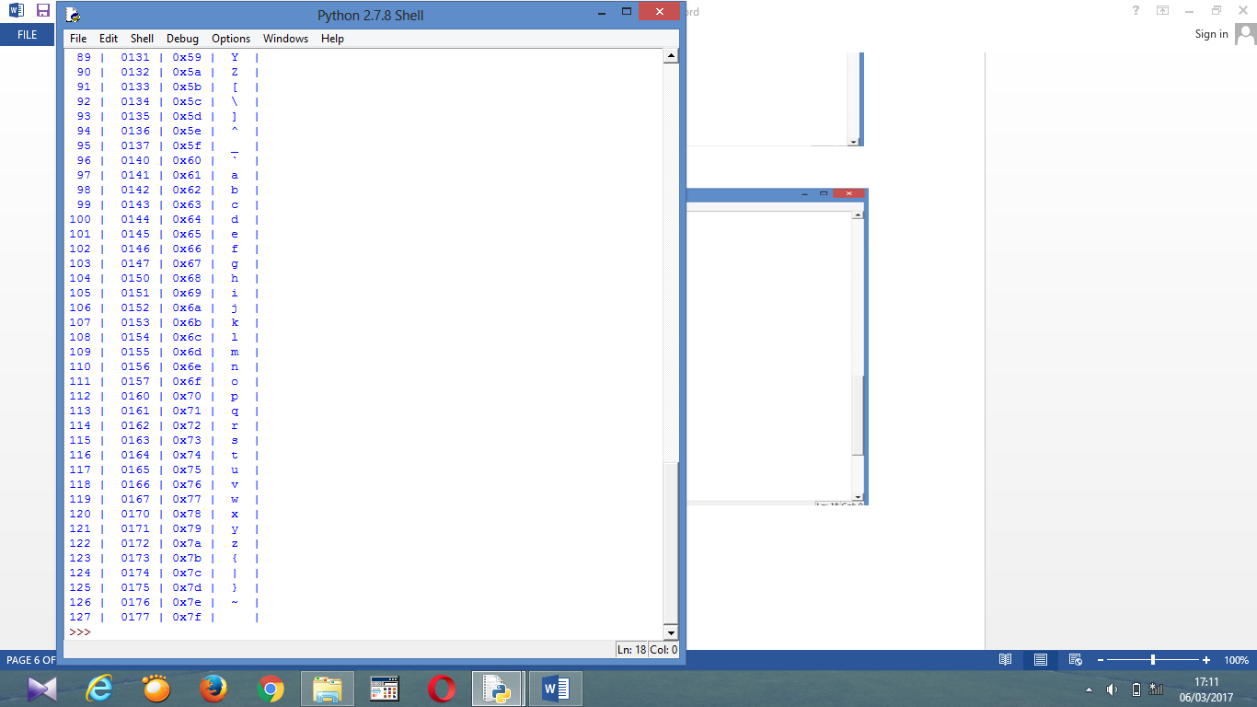

1. **Berikut ini adalah catatan tentang berbagai macam fungsi matematik yang terdapat dalam module “math”**

|  |
| --- |
| acos(...)  acos(x)    Return the arc cosine (measured in radians) of x. |
| acosh(...)  acosh(x)  Return the hyperbolic arc cosine (measured in radians) of x |
| asin(...)  asin(x)  Return the arc sine (measured in radians) of x. |
| asinh(...)  asinh(x)  Return the hyperbolic arc sine (measured in radians) of x |
| atan(...)  atan(x)  Return the arc tangent (measured in radians) of x. |
| atan2(...)  atan2(y,x)  Return the arc tangent (measured in radians) of y/x.  Unlike atan(y/x), the signs of both x and y are considered |
| atanh(...)  atanh(x)  Return the hyperbolic arc tangent (measured in radians) of x. |
| ceil(...)  ceil(x)  Return the ceiling of x as a float.  This is the smallest integral value >= x |
| copysign(...)  copysign(x, y)  Return x with the sign of y |
| cos(...)  cos(x)    Return the cosine of x (measured in radians). |
| cosh(...)  cosh(x)    Return the hyperbolic cosine of x. |
| degrees(...)  degrees(x)    Convert angle x from radians to degrees. |
| erf(...)  erf(x)    Error function at x.  erfc(...)  erfc(x)    Complementary error function at x. |
| exp(...)  exp(x)    Return e raised to the power of x. |
| expm1(...)  expm1(x)    Return exp(x)-1.  This function avoids the loss of precision involved in the direct evaluation of exp(x)-1 for small x. |
| fabs(...)  fabs(x)    Return the absolute value of the float x. |
| factorial(...)  factorial(x) -> Integral    Find x!. Raise a ValueError if x is negative or non-integral. |
| floor(...)  floor(x)    Return the floor of x as a float.  This is the largest integral value <= x. |
| fmod(...)  fmod(x, y)    Return fmod(x, y), according to platform C. x % y may differ. |
| frexp(...)  frexp(x)    Return the mantissa and exponent of x, as pair (m, e).  m is a float and e is an int, such that x = m * 2.**e.  If x is 0, m and e are both 0. Else 0.5 <= abs(m) < 1.0. |
| fsum(...)  fsum(iterable)    Return an accurate floating point sum of values in the iterable.  Assumes IEEE-754 floating point arithmetic |
| gamma(...)  gamma(x)    Gamma function at x |
| hypot(...)  hypot(x, y)    Return the Euclidean distance, sqrt(x*x + y*y). |
| isinf(...)  isinf(x) -> bool    Check if float x is infinite (positive or negative).  isnan(...)  isnan(x) -> bool    Check if float x is not a number (NaN). |
| ldexp(...)  ldexp(x, i)    Return x * (2**i). |
| lgamma(...)  lgamma(x)    Natural logarithm of absolute value of Gamma function at x. |
| log(...)  log(x[, base])    Return the logarithm of x to the given base.  If the base not specified, returns the natural logarithm (base e) of x. |
| log10(...)  log10(x)    Return the base 10 logarithm of x. |
| log1p(...)  log1p(x)    Return the natural logarithm of 1+x (base e).  The result is computed in a way which is accurate for x near zero. |
| modf(...)  modf(x)    Return the fractional and integer parts of x. Both results carry the sign  of x and are floats. |
| pow(...)  pow(x, y)    Return x**y (x to the power of y). |
| radians(...)  radians(x)    Convert angle x from degrees to radians. |
| sin(...)  sin(x)    Return the sine of x (measured in radians). |
| sinh(...)  sinh(x)    Return the hyperbolic sine of x. |
| sqrt(...)  sqrt(x)    Return the square root of x. |
| tan(...)  tan(x)    Return the tangent of x (measured in radians). |
| tanh(...)  tanh(x)    Return the hyperbolic tangent of x. |
| trunc(...)  trunc(x:Real) -> Integral    Truncates x to the nearest Integral toward 0. Uses the __trunc__ magic method. |